# **How-To:** Charging Batteries for the X-Copter

## Daniel Maurus, Stephan Gabor 2015.04.23. Ver.1.1

**Info:** This little tutorial describes how to charge our batteries for the X-Copter-Project

|  |  |  |
| --- | --- | --- |
|  | **Identifier:** | **Information:** |
| **Hardware:** | **Battery1 (LiPo_01)** | **Name:** FlightPower Hacker evo 20 4900mAh 6S1P  **Charging:** continuous: 20C, burst: 50C, charging: 1C  **Stored in:** Speicher[31] as LiPo_01 |
| **Battery2 (LiPo_02)** | **Name:** XTRON 40C 5000mAh 6S1P  **Charging:** continuous: 40C, burst: 80C, charging: 4C  **??** **Stored in:** Speicher[20] as LiPo_02 |
| **Battery3 (NiCd_01)** | **Charging:** loading current: 110mAh  **Stored in:** Speicher[19] as NiCa_01 |
| **Charging-Station:** | Ultra Duo Plus 60 |

We saved three configurations in the Ultra Duo for our batteries named: Lipo_01, Lipo_02 and NiCd_01

|  |  |  |  |  |
| --- | --- | --- | --- | --- |
| **Battery Overview** | | **LiPo_01** | **LiPo_02** | **NiCd_01** |
| Cell-Count: | | 6 | 6 | 4 |
| **Nominal** | Cell-Voltage | 3.7V | 3.7V |  |
| Total-Voltage | 22.2V | 22.2V |  |
| **Max.** | Cell-Voltage | **4.2**V | **4.2**V |  |
| Total-Voltage | **25**V | **25**V |  |
| **Min.** | Cell-Voltage | 3V | 3V |  |
| Total-Voltage | 18V | 18V |  |
| **Max. Charge Current** | | 4.9 A (1C) | 20 A(4C) |  |

**Hint: The maximum charge power is not above 80 W.**

**Important:** Warnings and security information are found in the documentantion-pdf:

6478_ULTRA DUO PLUS 60_de.pdf

You should read that before using the charging station as the information therein will not be in this tutorial.

# Charging Batteries:

**Current charged per charging session** = current * charging time

Refer to the datasheet of your batteries for information about max. current for charging.

**Standard-charging-current** is 1/10 of the capacity (1.7Ah capacity -> 170mA standard-charging-current)

1. Plug power cable to start charging device
2. Connect charging cables to charging station (red = plus, black = minus)
3. Recommend for LiPo’s: Connect cell adapter to “Balance” board and “Balance” board to charging station
4. We will use the CC/CV charging-mode for our batteries as fast-charging not supported by every type

# Step-by-Step-Solution

Overview

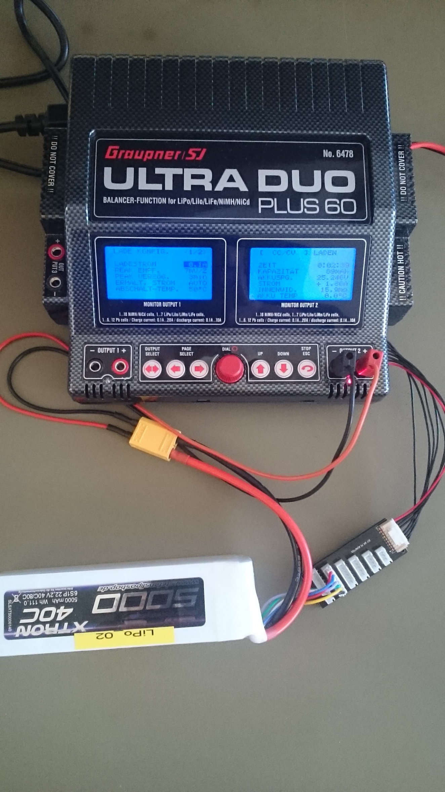

Control Interface

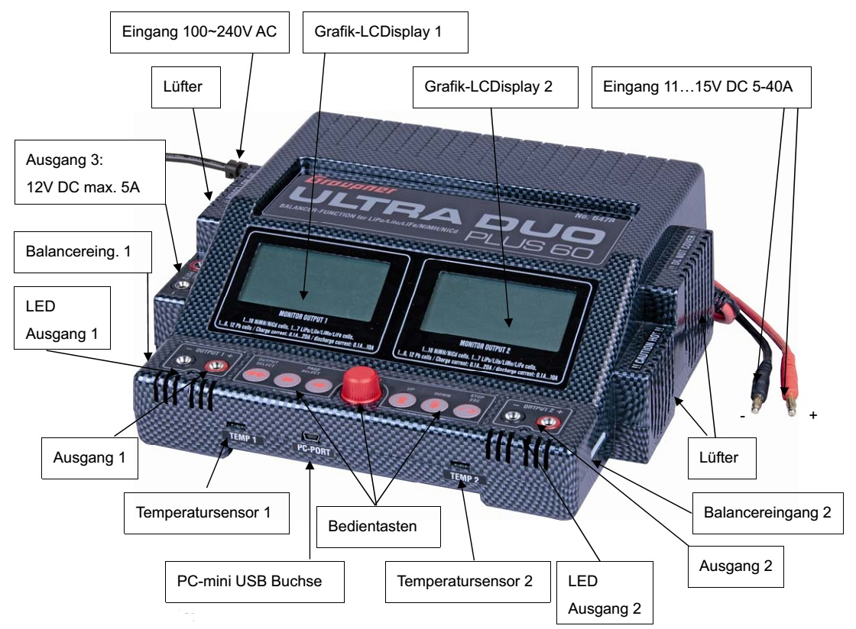

Enter “SPEICHER” item: turn red button(RB) to select “SPEICER” and hit RB

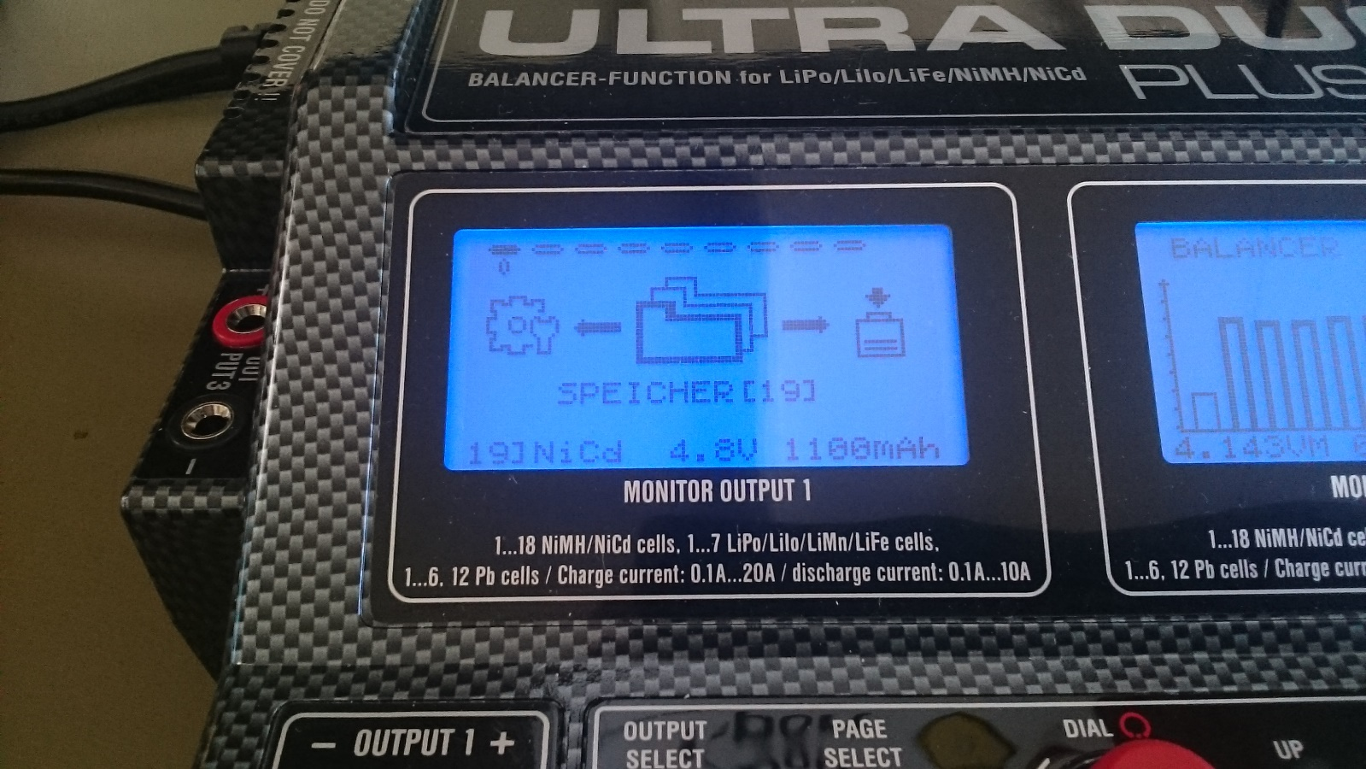

Choose save state

